MODULE 1: IT

What is Information Technology (IT)?
Information Technology (IT) refers to the use of computers, software, networks, and other digital systems to store, process, transmit, and manage information. It is the application and management of computer systems to achieve business goals.

Aspect | Information Technology (IT) | Computer Science (CS)
Focus | The use and management of computer systems, networks, and software. | The study of computation, algorithms, and the design of systems.
Goal | Applying technology to solve practical business problems. | Designing and building the foundation of computer systems and software.

Importance of IT in Today’s World
- Automation: Reduces manual effort and increases accuracy.
- Efficient communication: Email, chat, conferencing tools.
- Data storage & analytics: Helps in strategic decision-making.
- Global connectivity: Enables remote work and worldwide collaboration.
- Innovation: Drives progress in healthcare, finance, education, retail, etc.

4. Core Components of IT
Hardware
Physical devices such as computers, servers, routers, switches.
Software
Operating systems (Windows, Linux, macOS), applications (Office, browsers), and utilities (antivirus, backup tools).
Networking
LAN, WAN, MAN, PAN, routers, switches, modems—responsible for communication and resource sharing.
Data
Raw facts processed into information. Managed through databases and analytics tools.
People & Processes
IT professionals, users, workflows, policies, and best practices.

5. Computer Hardware (Interview-Style Explanation)
- Input devices: Keyboard, mouse, scanner.
- Output devices: Monitor, printer.
- CPU: “Brain” of the computer – contains ALU + Control Unit.
- Memory:
  - RAM: Volatile, temporary.
  - ROM: Non-volatile, permanent.
- Storage: Hard disk, SSD, optical drives.
Possible interview Q:
Q: What is the difference between RAM and ROM?
A: RAM is temporary and used for processing; ROM stores permanent instructions required for booting.

6. Computer Software
System Software
Operating systems, device drivers.
Application Software
Browsers, MS Office, database systems, media players.
Utility Software
Antivirus, disk cleanup, compression tools, backup utilities.

7. Networking & Internet
Networking connects multiple devices to share data and resources.
Types of Networks:
- LAN: Small area like office/home.
- WAN: Large geographical regions (Internet).
- MAN & PAN: Regional and personal networks.
Common Network Devices: Router, Switch, Modem, Hub, Access Point.
Interview Q:
Q: What is the difference between a Router and a Switch?
A: A router connects different networks; a switch connects devices within the same network.
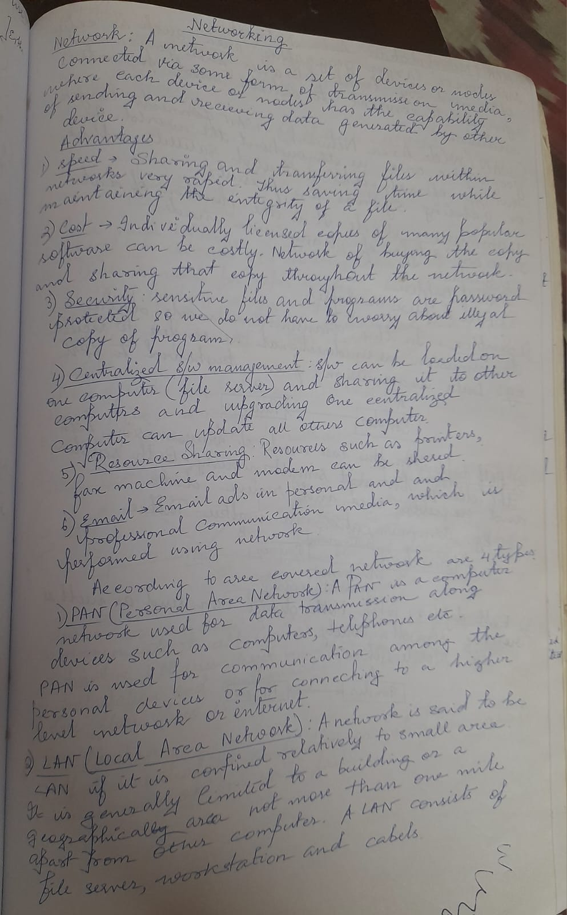
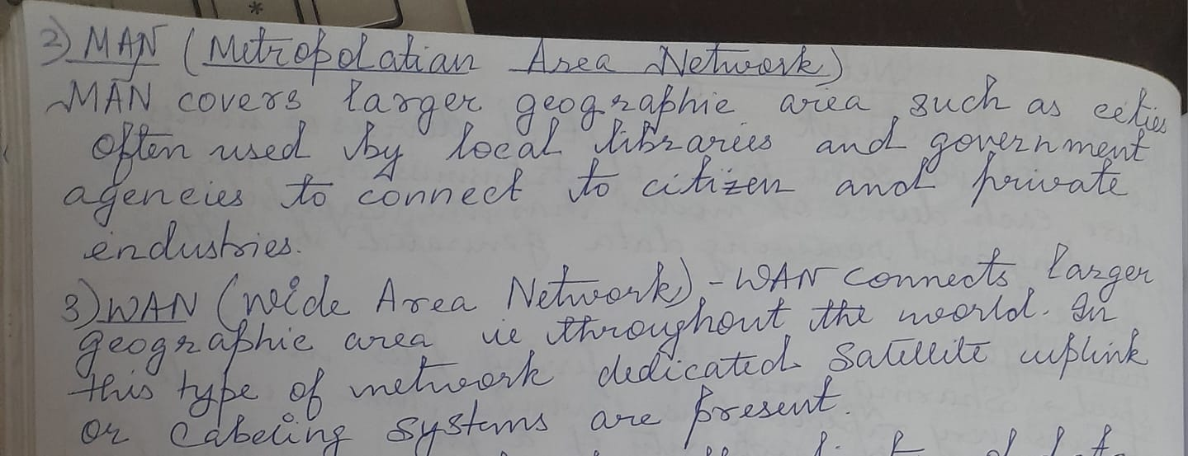

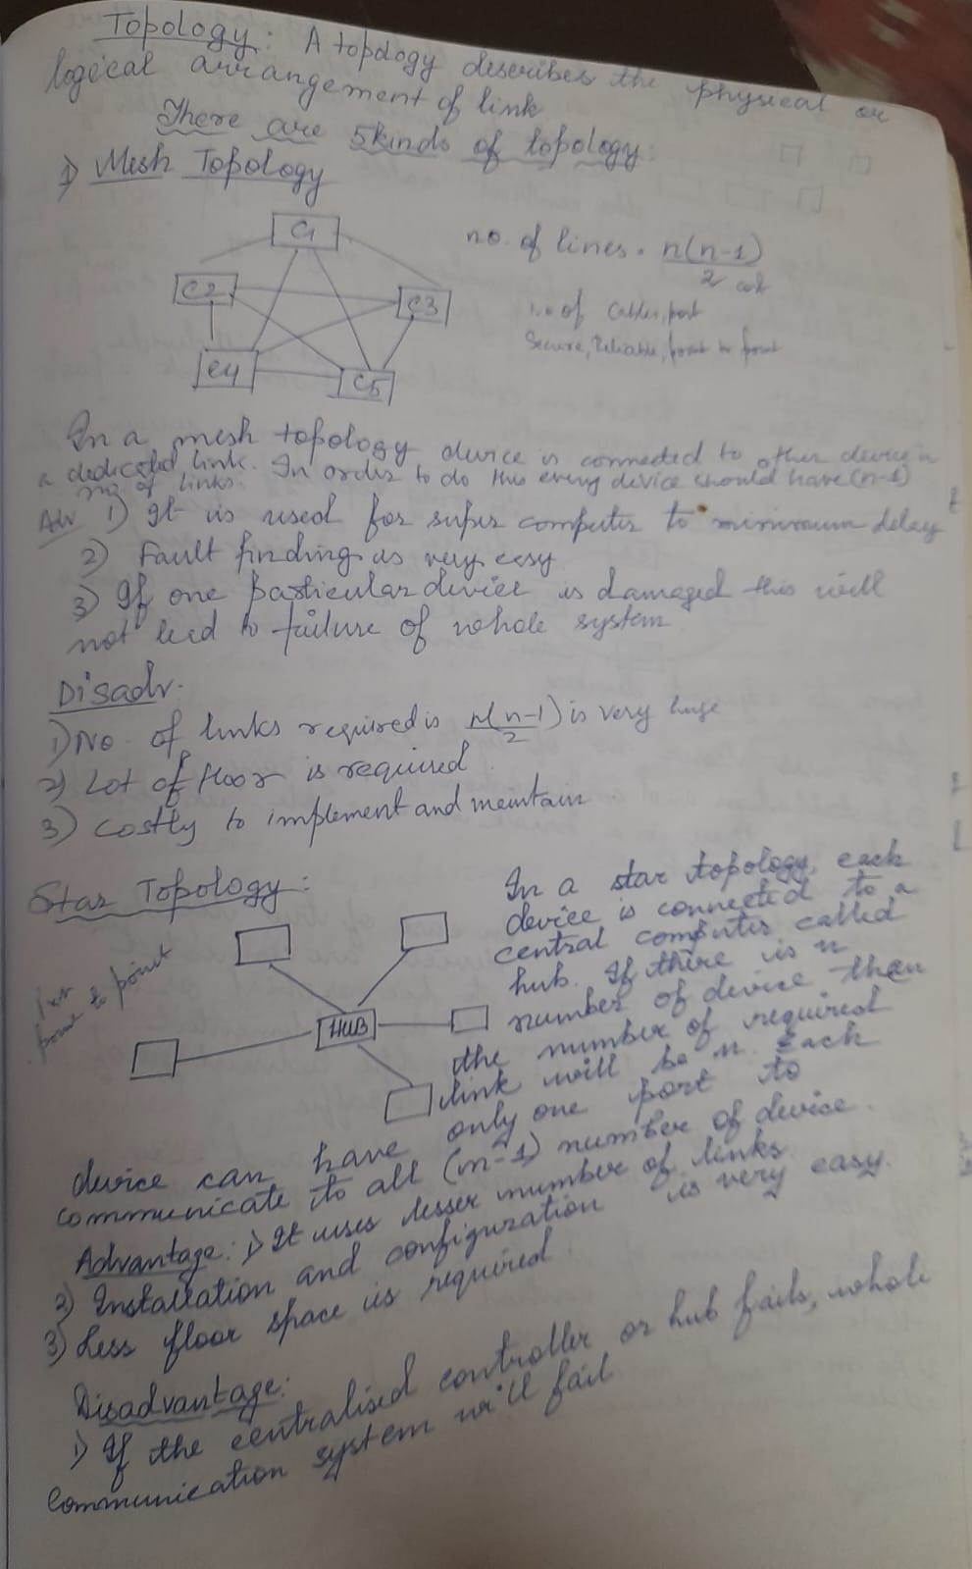
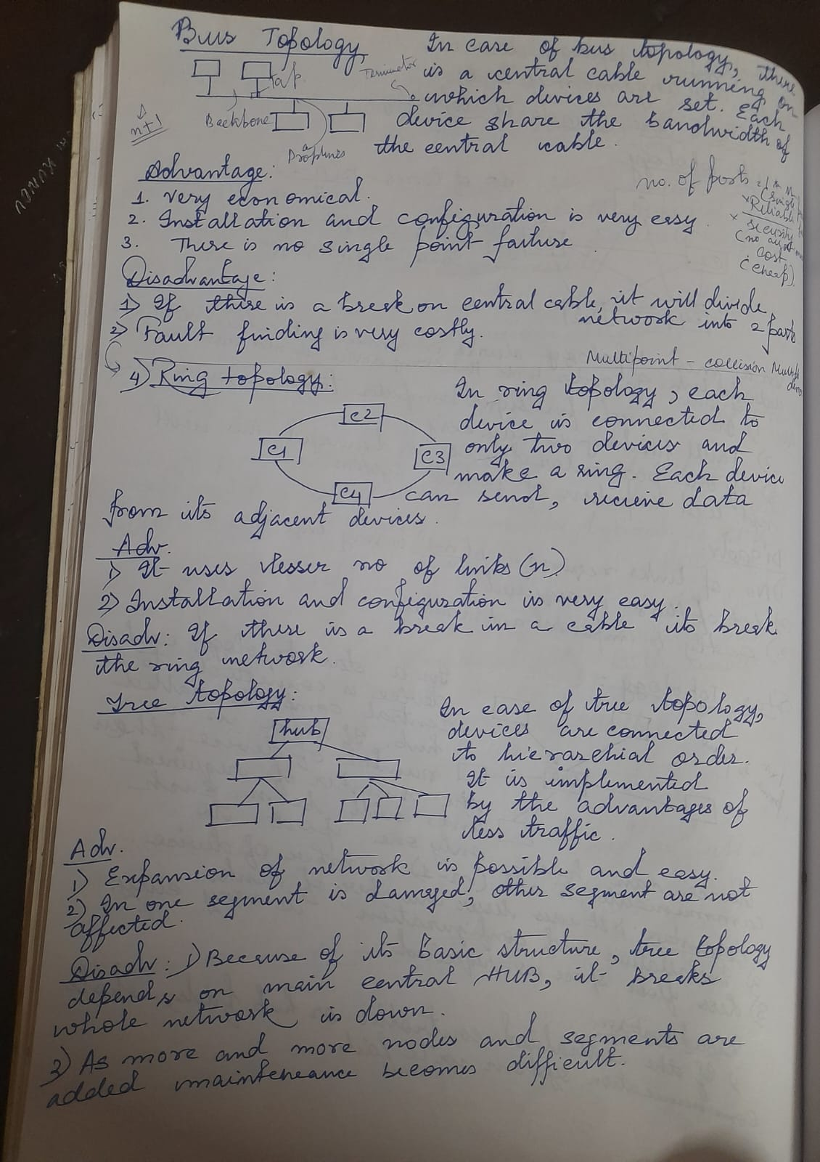
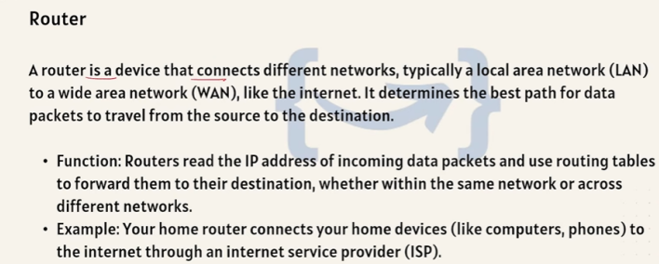
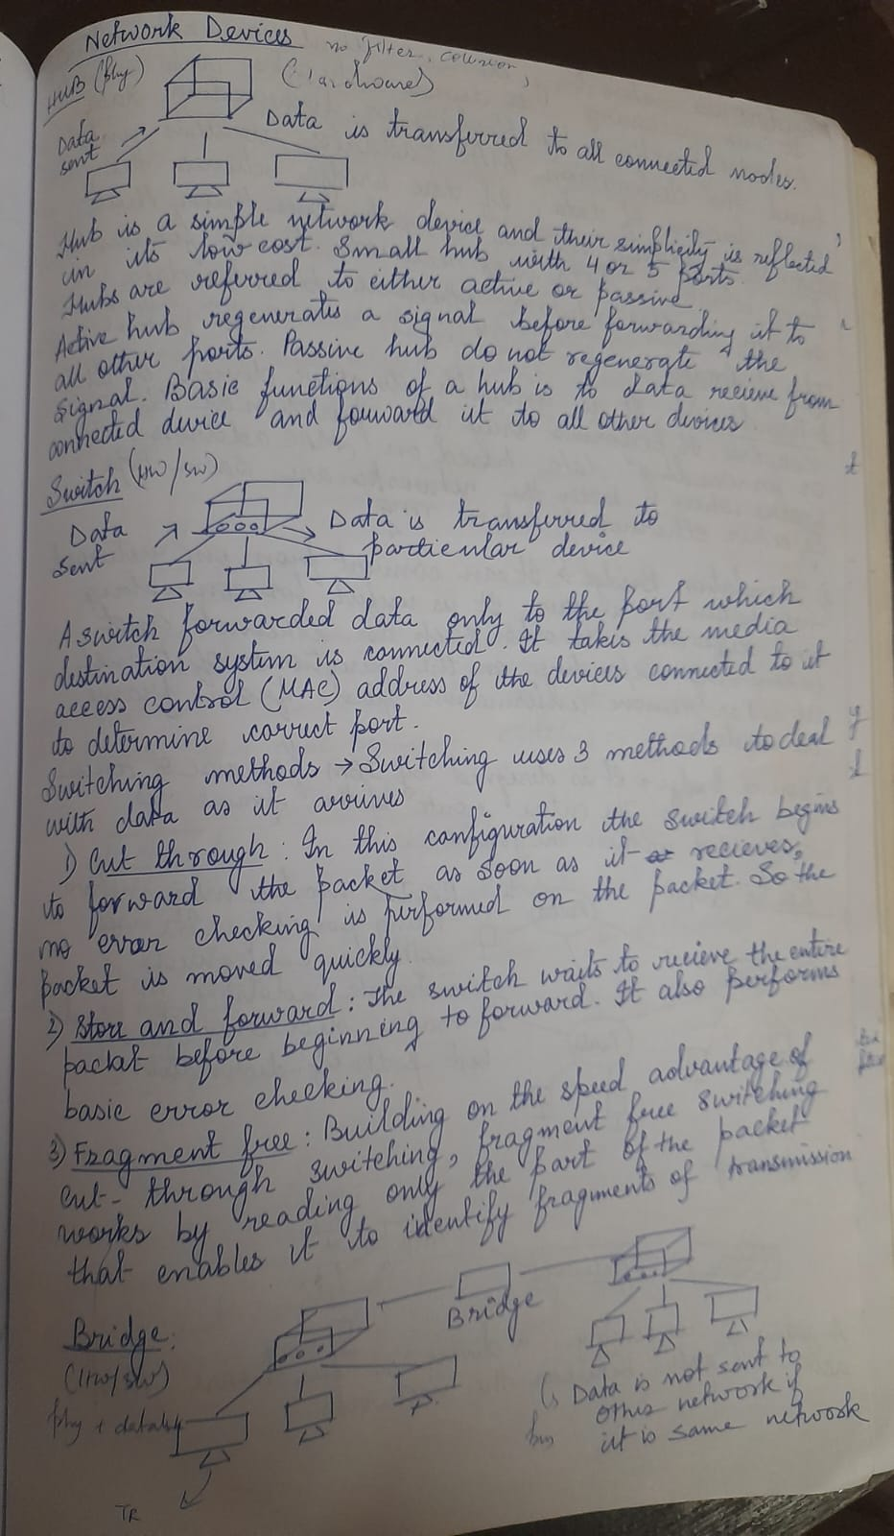
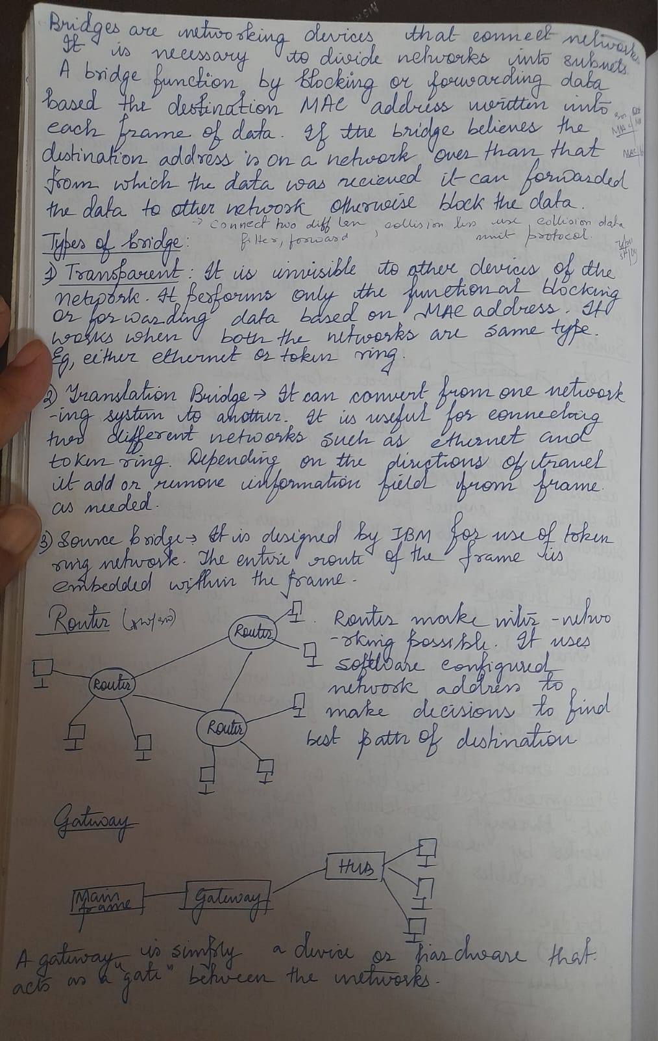
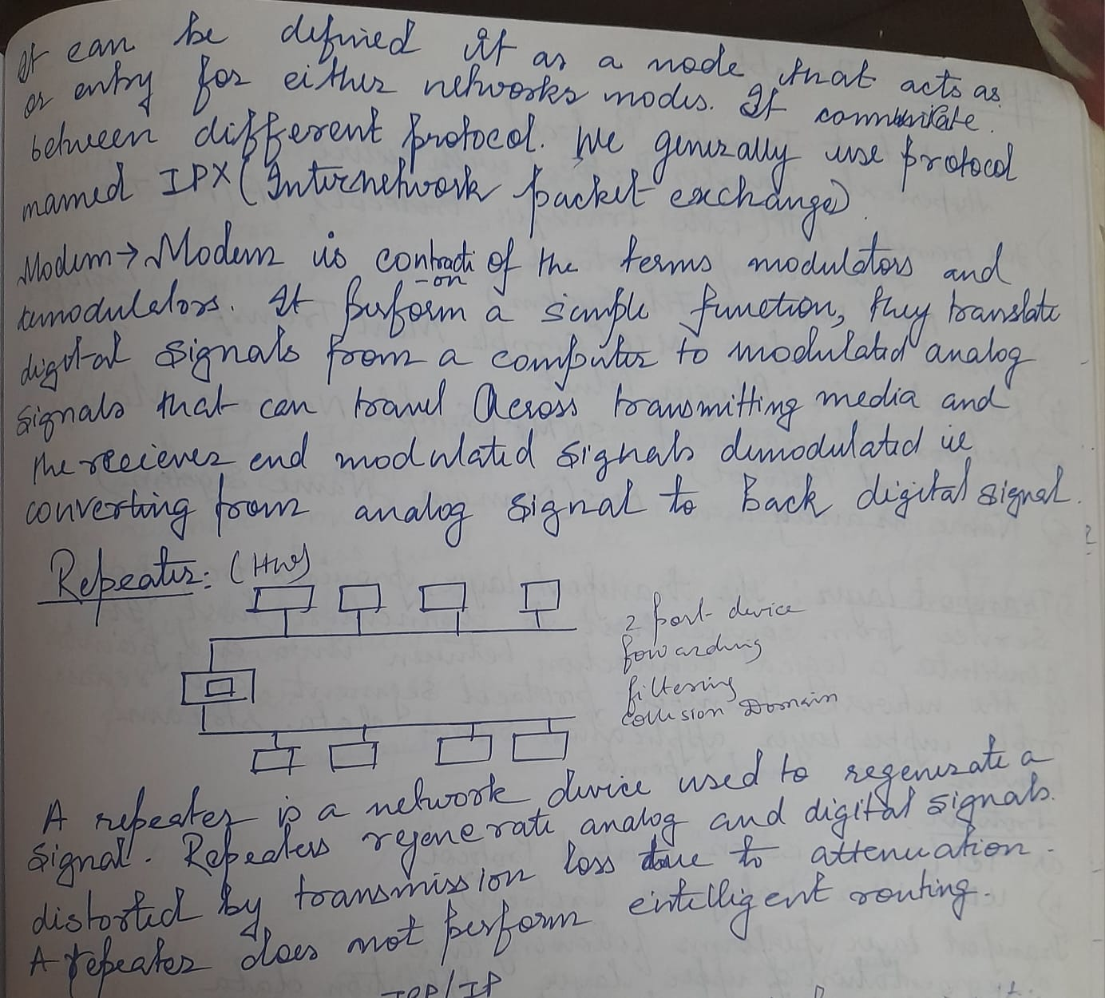
Protocol:
A protocol is a set of rules and standards that define how data is transmitted and communicated between devices in a network.
• TCP/IP: A foundational communication protocol suite that enables devices to connect and exchange data over the internet.
• FTP: A protocol used to transfer files between a client and a server over a network.
• SMTP: A protocol responsible for sending and routing emails across networks.
• HTTP: A protocol used for transferring web pages and data between a browser and a web server.
• HTTPS: A secure version of HTTP that encrypts data between the browser and server to ensure privacy and protection.

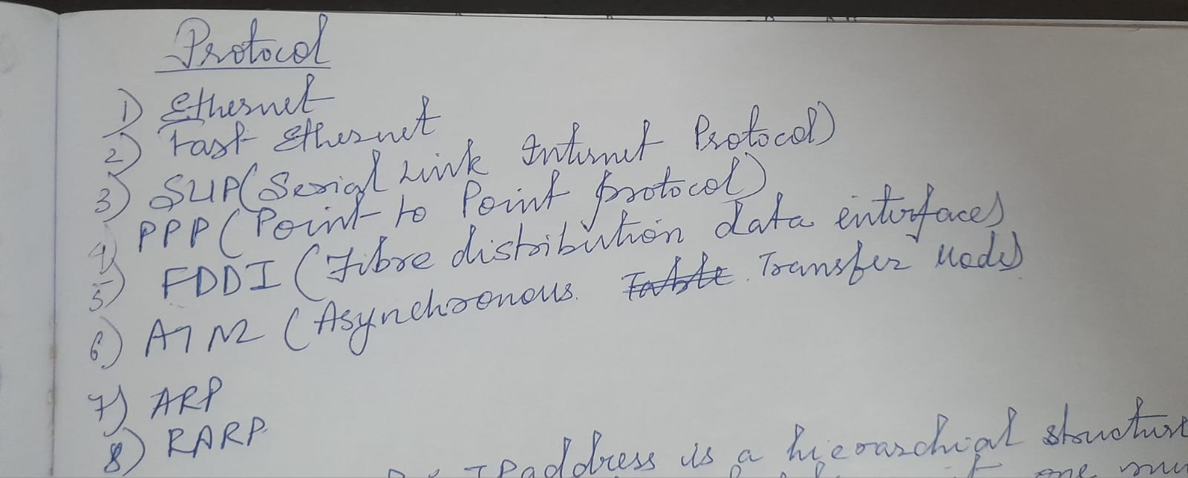

Database & DBMS
A Database stores structured information.
A DBMS (e.g., MySQL, SQL Server, Oracle) helps manage, retrieve, update, and secure that data.
Importance:
- Ensures data consistency
- Manages large datasets
- Provides security & access control
SQL is used to query and manipulate database data.
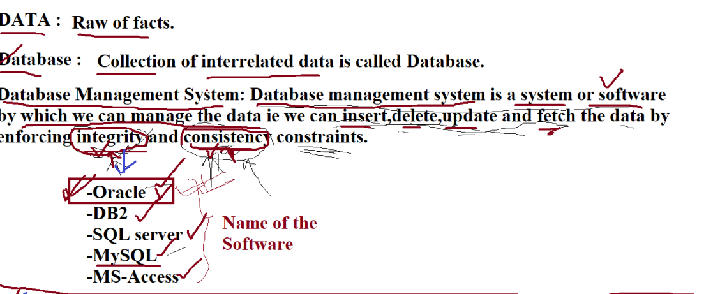
9. Information Security & Cybersecurity
Cybersecurity protects data, networks, and systems from digital threats.
Common Threats:
- Malware, virus
- Ransomware
- Phishing
- Unauthorized access
Security Measures:
Firewalls, encryption, authentication, backups, monitoring.

10. Cloud Computing
Cloud computing delivers computing resources like servers, storage, and applications over the internet.
Cloud Models:
- IaaS – Infrastructure
- PaaS – Platform
- SaaS – Software
Benefits: Scalability, cost-efficiency, remote access, less maintenance.
Examples: AWS, Azure, Google Cloud.

11. Emerging Technologies
- AI & ML: Automation, predictive systems, intelligent decision-making.
- IoT: Smart devices communicating via the internet.
- Blockchain: Secure, decentralized ledger.
- Big Data: Analysis of large volumes of data for insights.
12. Applications of IT in Business
- E-Commerce
- ERP (Enterprise Resource Planning)
- CRM (Customer Relationship Management)
- Remote work tools
- Business intelligence & analytics
- Automation and digital marketing
- Supply chain optimization
IT in Education (Short Notes)
- Enables online learning through e-learning platforms.
- Supports virtual classes using video conferencing tools.
- Provides access to digital libraries and online study materials.
- Uses smart classrooms and multimedia for better learning.
- Helps in online exams, attendance, and administration.

IT in Society (Short Notes)
- Improves communication through email, social media, and messaging.
- Supports online services like banking, shopping, and e-governance.
- Enables remote work and global collaboration.
- Enhances public services through smart city technologies.
- Makes daily life easier with digital payments and online entertainment.

KEY ROLE OF IT IN BUISNESS
Key Role | Description
Increased Efficiency | Automates repetitive tasks, reducing manual errors and increasing productivity and consistency².
Data-Driven Decisions | Provides advanced analytics tools to collect, analyze, and interpret data for strategic planning³.
Improved Communication | Enables real-time collaboration via tools like email, messaging, and video calls⁴.
Enhanced Customer Experience | Uses systems like CRM and chatbots for tracking customer preferences and providing instant service⁵.
Innovation & Competitiveness | Offers platforms for R&D, allowing companies to create innovative products and gain a competitive edge⁶.
Cybersecurity | Implements firewalls, encryption, and intrusion detection systems to protect sensitive data and the company's reputation⁷.
Scalability & Flexibility | Cloud computing offers scalable storage and remote access, enabling the business to grow and adapt operations as needed⁸.

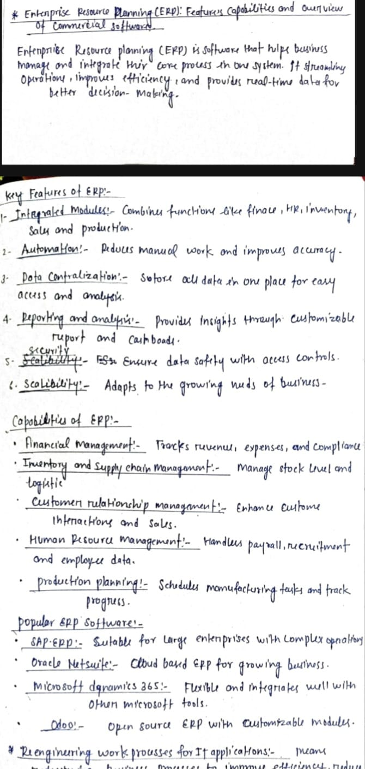
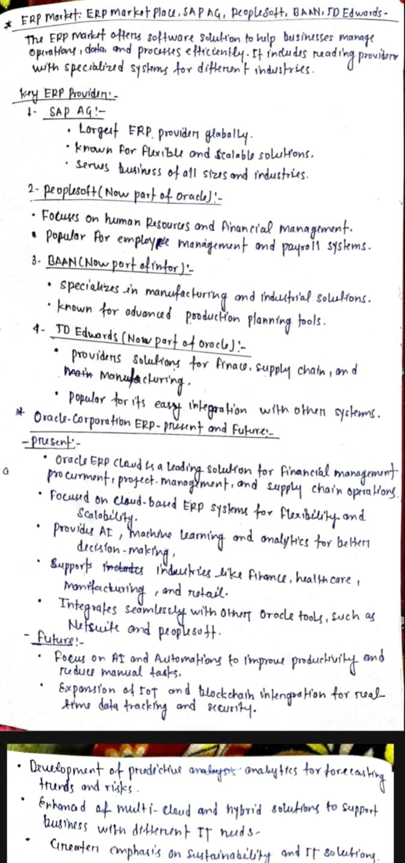

14. How ERP Works
- Centralized database: one source of truth
- End-to-end integration: sales → inventory → finance → production
- Automation: invoices, payroll, stock updates
- Real-time dashboards
- Modular structure: finance, HR, sales, SCM
- Cloud or on-premise deployment

How ERP Systems Work
ERP platforms integrate core functions into a single system using a central database²⁶.
- Centralized Database ²⁷: All departments store and access data from a single database, ensuring real-time consistency and preventing data duplication²⁸.
  - Example: A new sales order automatically updates inventory and accounting modules²⁹.
- Integration of Business Processes ³⁰: Workflows are interlinked (e.g., Sales $\to$ Inventory $\to$ Production $\to$ Finance), improving accuracy and efficiency³¹.
- Automation of Tasks ³²: Automates repetitive tasks like generating invoices, updating stock levels, and processing payroll, saving time and reducing manual errors³³³³³³³³.
- Modular Structure ³⁴: Systems are built using specific modules (e.g., Finance, HR, Inventory) that companies can implement as needed³⁵.

15. ERP vs CRM
ERP:
- Manages internal processes like finance, supply chain, HR, inventory.
CRM:
- Manages customer relationships, sales, marketing, customer support.
Aspect | ERP (Enterprise Resource Planning) | CRM (Customer Relationship Management)
Purpose/Focus | Manages internal business processes (efficiency and costs)⁴⁷. | Manages customer-related activities (relationships and sales growth)⁴⁸.
Key Functions | Accounting, Inventory, HR, Supply Chain, Manufacturing ⁴⁹. | Sales Tracking, Customer Support, Lead Management, Marketing Campaigns ⁵⁰.
Data Handled | Internal data (employees, suppliers, inventory, costs)⁵¹. | Customer data (leads, communication history, buying behavior)⁵².
Primary Users | Finance, HR, Operations, Logistics, Manufacturing teams⁵³. | Sales, Marketing, and Customer Support teams⁵⁴.

Types of ERP ✅
1. On-Premise ERP
Installed locally on the company’s own servers and managed by in-house IT staff.
✅ 2. Cloud ERP
Hosted on the vendor’s cloud servers and accessed via the internet.
✅ 3. Hybrid ERP
A combination of on-premise and cloud ERP features.
✅ 4. Open-Source ERP
ERP systems whose source code is publicly available and customizable (e.g., Odoo).
✅ 5. Industry-Specific ERP
ERP designed for specific sectors like manufacturing, healthcare, retail, or education.
✅ 6. Small Business ERP
Simplified ERP solutions tailored for small or growing businesses.

